BI Reprot

ACME Bike Emporium

BI Report - Part B: Group Project

INF30004 – Business Intelligence and Data Visualisation

Abstract

This analysis evaluates the efficiency of ACME's inventory management by examining key metrics, identifying systemic issues, and providing strategic recommendations for optimization.

Contents

1. Introduction 5

2. Inventory Management Analysis 6

2.1 Inventory Turnover Ratio 6

2.2 Safety Stock Efficiency Analysis 8

2.3 Overstock Efficiency Analysis 9

3. Comparative Analysis of Warehouse Performance 10

3.1 Warehouse performance by quantity 10

3.2 Warehouse performance by cost 10

3.3 Overall warehouse performance. 10

4. Current and Forecasted Product Availability Analysis. 10

4.1 Below Saftey Stock Analysis 10

4.2 Excess Stock Comparison 10

4.3 Over-Stock Analysis of each Product 10

5. Excess Inventory Analysis. 10

6. Conclusion 10

7. References. 10

Infographic

Executive summary

This report highlights the strategic transformation of ACME’s inventory management practices through the integration of advanced data analytics and artificial intelligence (AI) to enhance business intelligence. Our consultancy will thoroughly analyze key areas, including inventory management (inventory turnover ratio, safety stock efficiency, and overstock efficiency), warehouse performance (quantity, costs, time dimension, and location), actual and forecasted product availability (top three products below safety stock threshold, excess stock products, overstock products), excess stock analysis (consequences and effects), and recommendations based on four key analytical criteria.

In analyzing inventory management, data indicates a stable inventory turnover ratio from 2022 to 2023, except for a spike in Q3 2023, suggesting efficient inventory management. This spike, indicative of massive or clearance sales, points to failures in forecasting and demand prediction. Optimal inventory management requires on-hand quantities to be at or slightly above the safety stock threshold. However, most on-hand quantities are below this threshold, except for the overstocked mountain bike product. Overstocking, consistent across most products, leads to increased holding costs and product obsolescence due to overestimating demand, market changes, seasonal fluctuations, and real-time variations.

For warehouse performance, this analysis emphasizes foresight and scenario analysis under both negative (increased churn rate, lower productivity) and positive (business growth, increased cost of goods sold) conditions. These scenarios reflect challenges such as inflation, interest rate fluctuations, and material shortages post-COVID-19. Simulations reveal that all warehouses adapt well, avoiding overstock and missed sales due to effective inventory management practices.

Regarding product availability, most products fall below the safety stock threshold, while kid bikes and mountain bikes have excess stock. Balancing safety stock and overstock, as well as avoiding missed sales and overstock costs, remains challenging.

Excess inventory management involves disposing of surplus stock to free up funds and improve financials. With ACME's overstock reaching 31%, improved inventory management is essential to reduce costs, storage, and security expenses. Enhanced systems can mitigate excess inventory while adapting to demand changes.

Recommended solutions include enhancing demand forecasting models, reviewing inventory levels for Just-in-Time (JIT) management, tracking real-time inventory systems, implementing adaptable inventory management, and conducting cost-benefit analyses.

# 1. Introduction

Effective inventory and warehouse management is essential for preserving competitive advantage and operational effectiveness in the fast-paced market climate of today. This report, written for the INF30004: Business Intelligence and Data Visualisation course, provides a thorough examination of ACME's inventory and warehouse performance through the use of advanced data analytics and artificial intelligence (AI). By optimising inventory turnover ratios, safety stock efficiency, and overall warehouse performance across a range of market scenarios, we want to improve ACME's business intelligence capabilities. Key aspects addressed include inventory turnover ratios, on-hand quantities, safety stock levels, and overstock situations. Accurate demand forecasting, real-time inventory tracking, and dynamic management practices are essential to reduce holding costs and mitigate risks associated with overstock and stockouts (Raj et al., 2022; Wang et al., 2016). The report also evaluates warehouse performance taking location, amount, cost, and time into account. Scenario analysis evaluates how variables like post-COVID-19 material shortages, inflation, and interest rate swings would affect operations. According to the research, in order to maintain resilience against market disruptions, strategies must be flexible and adaptive (Marziali et al., 2021; Lozic & Cikovic, 2021).

Our suggestions include incorporating just-in-time (JIT) inventory procedures and improving demand forecasting models using cutting-edge methods like machine learning. By implementing these tactics, ACME will be able to better satisfy customers, optimise storage costs, and balance supply and demand. (Bhale & Bedi, 2024).

# 2. Inventory Management Analysis

Effective inventory management is crucial for ACME's warehouses to ensure a balance between supply and demand, optimize storage costs, and enhance customer satisfaction. This analysis focuses on key metrics such as Inventory Turnover Ratio and On-hand Quantity to evaluate the efficiency of inventory management at ACME's warehouse WH-US-03. By examining these metrics over time, we can gain insights into the warehouse's performance and identify areas for improvement.

## 2.1 Inventory Turnover Ratio

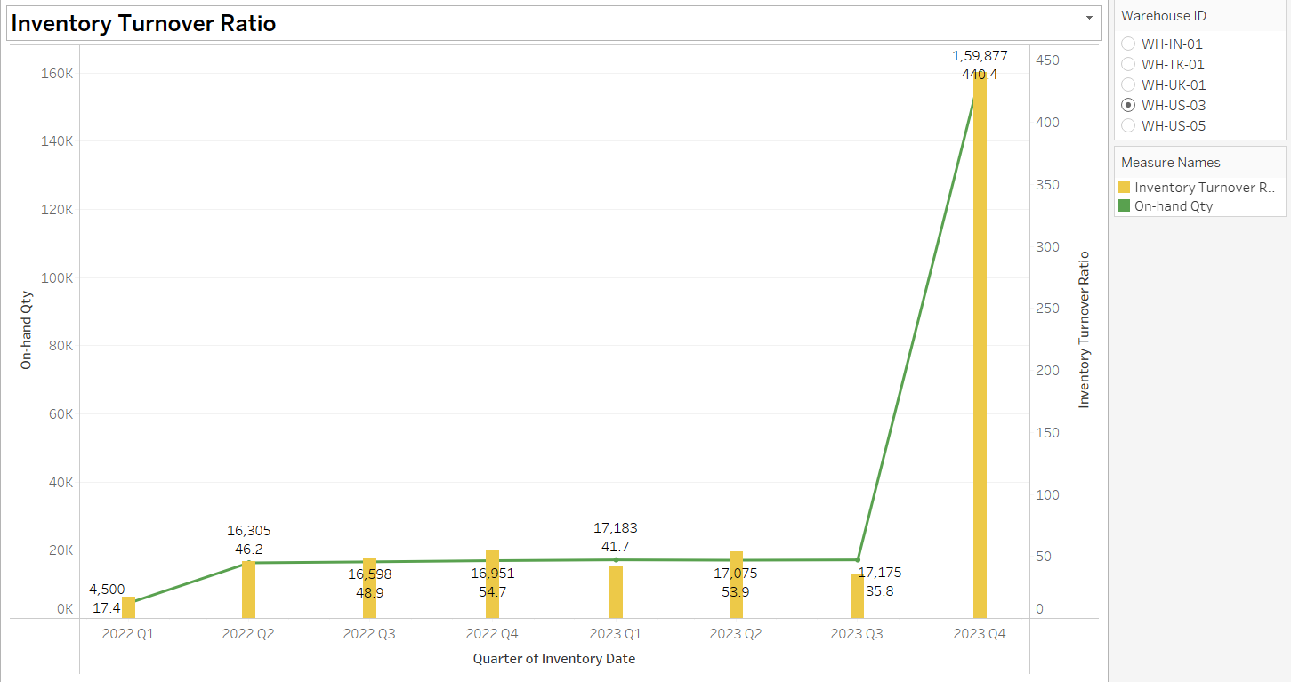**Figure 1**: Inventory turnover ratio

**Key Findings**

1. **Stable Inventory Turnover (2022 Q1 - 2023 Q3):**

* The Inventory Turnover Ratio remained low and stable, fluctuating between 17.4 and 54.7, indicating consistent sales and replenishments. On-hand quantities were also stable, ranging from 4,500 to 17,183 units, suggesting balanced inventory levels without significant overstocking or stockouts.

1. **Significant Spike in 2023 Q4:**

* A drastic spike in the Inventory Turnover Ratio to 440.4 in 2023 Q4, with On-hand Quantity rising sharply to 159,877 units, suggests a massive sales surge or inventory clearance.

**Forecasting Issues**

* The significant spike in 2023 Q4 suggests potential inaccuracies in demand forecasting. The sudden increase in both turnover ratio and on-hand quantity indicates that previous forecasts did not anticipate this surge.
* It is essential to evaluate the factors that led to this unexpected demand, whether seasonal trends, promotional activities, or market changes, to improve future forecasting accuracy.

**Quarterly Trends**

1. **2022 Q1 - 2023 Q3:**

* Stable Inventory Turnover Ratio and On-hand Quantities suggest consistent inventory management. Minor fluctuations indicate stable sales and replenishments.

1. **2023 Q4:**

* A sharp increase in both metrics likely due to external factors such as promotions, seasonal demand, or strategic clearance.

**Recommendations**

To address the significant spike in 2023 Q4, ACME should investigate the underlying factors, such as marketing campaigns, seasonal trends, and external market influences. Enhancing demand forecasting models by incorporating historical sales data, market trends, and promotional activities will improve accuracy and account for unexpected surges. Regularly reviewing and adjusting inventory levels to align with forecasts using just-in-time (JIT) practices can reduce holding costs. Implementing real-time inventory tracking systems and conducting regular audits will maintain accuracy and control. Additionally, developing specific strategies for seasonal peaks and promotional events, in coordination with marketing and sales teams, will ensure adequate stock levels without overburdening storage capacity.

## 2.2 Safety Stock Efficiency Analysis

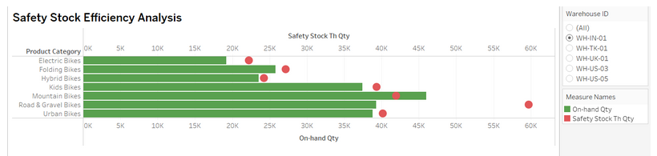**Figure 2**: Safety stock efficiency

**Key Findings**

1. **Safety Stock Levels vs. On-hand Quantities:**

* For all product categories, the Safety Stock Threshold Quantity (red dots) and the On-hand Quantity (green bars) show significant disparities.
* Mountain Bikes, Road & Gravel Bikes, and Hybrid Bikes have the highest on-hand quantities, significantly exceeding their safety stock thresholds.
* Electric Bikes and Kids Bikes also show a considerable excess in on-hand quantities over safety stock thresholds.

1. **Potential Overstock:**

* The excess on-hand quantities across various product categories suggest potential overstock situations, which could lead to higher holding costs and increased risk of inventory obsolescence.

1. **Safety Stock Adherence:**

* The safety stock levels are consistently lower than on-hand quantities, indicating that the warehouse maintains sufficient inventory to avoid stockouts but might be overstocking.

**Forecasting Issues**

1. **Overestimation of Demand**: The significant excess in on-hand quantities suggests that the demand forecasting models might be overestimating future demand, leading to higher than necessary inventory levels.
2. **Inaccurate Safety Stock Levels**: The disparities between safety stock thresholds and on-hand quantities indicate that safety stock levels may not be accurately reflecting the actual demand variability and lead times.

**Quarterly Trends**

1. **Stable On-hand Quantities:** Throughout the quarters, on-hand quantities for most product categories remained stable, consistently exceeding safety stock thresholds.
2. **Lack of Seasonal Adjustment:** The analysis does not show significant quarterly adjustments for seasonal demand, suggesting a static approach to inventory management rather than dynamic adjustments based on seasonal trends.

**Recommendations**

ACME should enhance demand forecasting with comprehensive data and advanced techniques and dynamically adjust safety stock levels based on real-time data. Implement inventory optimization tools and real-time tracking for better control, conduct regular audits, and improve coordination with sales and marketing teams to align inventory with promotional activities and accurate demand predictions, minimizing overstocking.

## 2.3 Overstock Efficiency Analysis

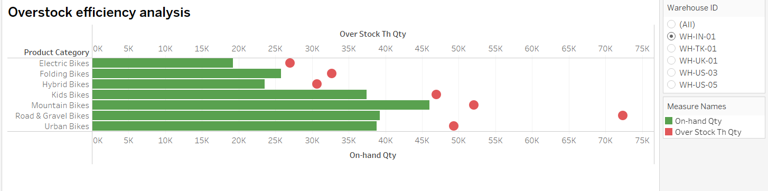**Figure 3**: Overstock efficiency

**Key Findings**

1. **Significant Overstock:**

* Mountain Bikes and Road & Gravel Bikes have the highest on-hand quantities, significantly exceeding their overstock threshold quantities.
* Folding Bikes and Hybrid Bikes also show notable excesses in on-hand quantities compared to their overstock thresholds.

1. **Potential Overstock Costs:**

* The substantial excess in on-hand quantities indicates potential overstock issues, which can lead to increased holding costs and risk of inventory obsolescence.

1. **Safety and Overstock Thresholds:**

* On-hand quantities for all product categories exceed the overstock thresholds, suggesting that the inventory levels are not aligned with optimal stock management practices.

**Forecasting Issues**

1. **Overestimation of Demand:** The substantial excess in on-hand quantities suggests that the current demand forecasting models may be overestimating future demand, leading to higher than necessary inventory levels.
2. **Static Overstock Thresholds:** The overstock thresholds appear to be static, not reflecting real-time demand fluctuations, seasonal trends, or market changes.

**Quarterly Trends**

1. **Consistent Overstock:**

* Throughout the quarters, the on-hand quantities for most product categories have remained consistently above the overstock thresholds.
* This indicates a lack of dynamic adjustment in inventory levels in response to actual sales and demand variations.

1. Lack of Seasonal Adjustment:

* No significant adjustments for seasonal demand indicate inventory management doesn't account for seasonal variations.

**Recommendations**

Refine demand forecasting with comprehensive data and advanced techniques. Dynamically adjust overstock thresholds based on real-time demand. Implement inventory optimization tools to balance holding costs with service levels and enhance real-time inventory tracking. Conduct regular audits to ensure accuracy and improve coordination with sales and marketing teams to align inventory with promotional activities and accurately predict demand spikes. This will minimize overstocking and optimize inventory management.

# 3. Comparative Analysis of Warehouse Performance

Time, cost, quality, productivity, location, and technology have significant impacts on warehouse performance (Hedler Staudt et al., 2015). Quality, response time, total warehousing cost, productivity, and supply chain management are key determinants of warehouse performance (Bhale & Bedi). From the data set, critical variables affecting warehouse performance are quantity, cost, time, and location. Integrating these with the Just-in-Time (JIT) model prioritizes immediate inventory availability, reducing emphasis on inventory duration due to limited data.

## 3.1 Warehouse performance by quantity

Risk factors in inventory management include overstock and missed sales. Overstock occurs when on-hand quantity exceeds the threshold, while missed sales occur when it falls below the safety stock threshold. The Just-in-Time (JIT) model optimizes inventory management (Yang et al., 2021). Productivity and churn rate influence on-hand quantity, but JIT facilitates efficient management (Mankazana & Mukwakungu, 2018).

**Figure 4**: Actual quantity performance with scenarios simulation

**Figure 5**: Forecasted quantity performance with scenarios simulation

The visualizations compare warehouse performance under actual and forecast scenarios, considering a 5% churn rate (Mustafa et al., 2021) and 10% productivity difficulty (McPhail et al., 2024). Key insights: reduced overstock risks due to lower on-hand quantities, increased missed sales risks from potential stockouts, and the importance of the JIT model in maintaining balanced inventory levels. Adaptability is crucial for resilience against disruptions.

The visualizations analyze warehouse performance with a 5% churn rate and 10% productivity difficulty under actual and forecast conditions, categorizing warehouses as overstock, missed sales, or just-in-time (JIT).

In the actual scenario, WH-US-05 faces overstock (80,631) and missed sales (51,100). WH-TK-01 manages JIT effectively (22,301) but shows overstock (21,270). WH-UK-01 experiences overstock (25,995).

In the forecast, WH-US-05 shows mixed JIT performance (34,731), high overstock (37,785), and missed sales risks (45,358). WH-TK-01 demonstrates JIT (16,335) but shows high overstock (44,023). WH-UK-01 shows overstock (53,949).

Insights: WH-TK-01 demonstrates effective JIT management. WH-US-05 and WH-UK-01 show consistent overstock, with WH-US-05 facing missed sales risks. The JIT model is optimal for WH-TK-01, but WH-US-05 and WH-UK-01 need better inventory practices.

## 3.2 Warehouse performance by cost

The visualizations compare Cost of Goods Sold (COGS) across warehouses under actual and forecast scenarios, with a 10% COGS increase and 20% business growth. WH-UK-01 and WH-TK-01 show significant increases, indicating sensitivity to cost changes. WH-US-03 and WH-IN-01 exhibit variability, highlighting the need for tailored cost management and growth strategies to ensure stable and efficient warehouse operations (JNC et al.)

## 3.3 Overall warehouse performance.

**Figure 6**: India vs U.S warehouse overall performance with all scenario's simulation

The visualizations provide a comparative analysis of overall warehouse performance under actual and forecast conditions, considering 20% business growth, 5% COGS change, 5% churn rate, and 10% productivity difficulty. The simulation indicates that all warehouses adapt well to these scenarios, avoiding overstock and missed sales due to effective inventory management strategies. This report emphasizes future foresight and scenario analysis, not current situations.

For example, the India warehouse (WH-IN-01) and the Seattle US warehouse (WH-US-05) demonstrate successful Just-in-Time (JIT) inventory management. WH-IN-01 shows a COGS change of $9,575,228.88 and maintains an on-hand quantity of 50,725, while WH-US-05 has a higher COGS change of $12,543,899.76 and an on-hand quantity of 74,444. WH-IN-01 displays more efficient cost management compared to WH-US-05, despite both maintaining optimal inventory levels to prevent overstock and missed sales.

The analysis suggests that while JIT is effective, regional cost differences impact overall performance. To mitigate these costs, strategies such as optimizing the supply chain, renegotiating supplier contracts, or improving operational efficiency could benefit WH-US-05, aligning better with cost management goals (Raj et al., 2022).

# 4. Current and Forecasted Product Availability Analysis.

## 4.1 Below Saftey Stock Analysis

**Figure 7**: Top 3 products below safety stock threshold

Note: Below-Safety-Stock is calculated by On-hand Quantity – Below Safety Stock Threshold Quantity.

**Key Findings**

1. **Consistent Below-Safety Stock Products:**

* **Road & Gravel Bikes (Yellow)**: This category consistently has the highest number below safety stock in all warehouses across all quarters\. This indicates a recurring issue with maintaining adequate stock levels for this category.
* **Hybrid Bikes (Red)**: Also consistently below safety stock, highlighting a potential problem in inventory forecasting or supply chain issues specific to these bikes.
* **Electric Bikes (Blue)**: Similarly, Electric Bikes also frequently fall below the safety stock threshold, though not as drastically.

1. **Forecasting Issues:**

The data for 2023 Q4 is forecasted, and it shows a significantly higher number of products below the safety stock threshold compared to other quarters. This suggests that the current forecasting model may not be adequately capturing the inventory needs, leading to potential stockouts (Chopra & Meindl, 2016).

1. **Quarterly Trends:**

Over the analysed periods, there is a noticeable fluctuation in the number of products below the safety stock threshold. This variability indicates that there might be underlying issues with demand planning or supply chain disruptions affecting the ability to maintain optimal stock levels. The consistent presence of certain categories (e.g., Road & Gravel Bikes, Hybrid Bikes) below the safety stock threshold suggests systemic issues in managing these product lines (Silver, Pyke, & Thomas, 2016).

1. **Recommendations:**

* **Focus on High-Risk Categories:** Given the consistent below-safety stock levels for Road & Gravel Bikes, Hybrid Bikes, and Electric Bikes, ACME should prioritise these categories for inventory optimisation. This might include renegotiating supplier contracts, increasing safety stock levels, or improving demand forecasting accuracy for these specific categories (Krajewski, Malhotra, & Ritzman, 2018).

## 4.2 Excess Stock Comparison

**Figure 8**: Excess stock comparison

Note: Excess stock is calculated using the formula: On-hand Quantity - 3(Outflow Quantity). The visualisation uses a stacked bar chart to represent the excess stock, with each product category identified by a unique colour.

**Key Findings**

1. **High Excess Stock in Specific Categories:**

* **Kids Bikes (Cyan):** This category shows a significant excess stock, particularly in the forecasted data for 2024 Q1. This indicates that the current inventory levels for Kids Bikes are far beyond what is required based on the outflow rate.
* **Mountain Bikes (Green):** Similar to Kids Bikes, Mountain Bikes also exhibit high levels of excess stock, especially in the forecasted quarter. This suggests potential overstocking issues that need to be addressed.

1. **Forecasting Issues:**

The data for 2024 Q1 is forecasted, showing a considerable increase in excess stock across all product categories compared to previous quarters. This implies that the current forecasting model may not be accurately predicting demand, leading to overstocking (Chopra & Meindl, 2016).

1. **Quarterly Trends:**

The visualization indicates a steady increase in excess stock levels from 2022 Q1 to 2024 Q1. This trend suggests that the current inventory management practices are not adequately addressing the issue of excess stock, leading to accumulating overstock over time (Silver, Pyke, & Thomas, 2016).

1. **Recommendations:**

* **Review and Refine Forecasting Models:** The significant increase in excess stock in the forecasted data for 2024 Q1 highlights the need to review and enhance the current forecasting models. Incorporating advanced techniques such as machine learning algorithms for demand forecasting could provide more accurate predictions and help in maintaining optimal stock levels (Wang et al., 2016).

## 4.3 Over-Stock Analysis of each Product

**Figure 9**: Overstock analysis by products

**Key Findings:**

1. **Mountain Bikes Overstock Issue:**

Mountain Bikes (Purple): This category shows a consistent increase in on-hand quantity each quarter, reaching and surpassing the overstock threshold in the forecasted data for 2023 Q4. This indicates a potential overstocking issue that needs immediate attention (Chopra & Meindl, 2016).

1. **Forecasting Implications:**

The data for 2023 Q4 is forecasted and indicates that the on-hand quantity for Mountain Bikes will exceed the overstock threshold significantly. This suggests that the current inventory management practices are not effectively controlling stock levels, leading to potential overstock situations (Silver, Pyke, & Thomas, 2016).

1. **Quarterly Trends:**

The visualisation shows a steady increase in the on-hand quantity of Mountain Bikes over the analysed periods. This trend suggests that the current inventory management practices might be leading to over-accumulation of stock, particularly for Mountain Bikes (Wang et al., 2016).

1. **Recommendations:**

**Implement Dynamic Inventory Management:** Adopting dynamic inventory management practices, such as just-in-time (JIT) inventory, can help in maintaining optimal stock levels and reducing the risk of overstocking. Regularly reviewing and adjusting inventory policies based on real-time data can further enhance inventory efficiency (Nahmias & Olsen, 2015).

# 5. Excess Inventory Analysis.

Excessive product generation is regarded as one of the primary reasons of mismanagement and inaccurate warehouse and inventory predictions. It may appear that having excess is advantageous at times, but it is advisable to keep stocks as low as possible (Braglia, 2016). Excess inventory causes longer holding periods, lower inventory turnover rates, and unexpected events (missed sales and overstock products) because the manufacturing area lacks accurate and up-to-date information (Marziali, 2021). Identifying and disposing surplus inventory allows firms to free up funds attached to slow moving or outmoded products, increasing their financial situation.

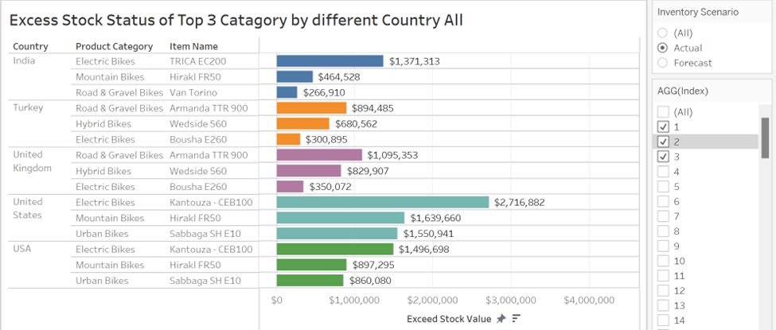**Figure 10**: Excess stock Status of top 3 category across multiple country warehouses

The visualization illustrates the top three product categories' possible excess costs, which ACME could consider reducing in order to reduce its excessive stock restrictions. When there is more merchandise on hand than there is safe stock, it is considered excess stock. To reduce the risk of uncertain consumer demand, businesses might modify delivery arrangements and inventory levels, with a major focus on reviewing safety stock to safeguard (Braglia, 2016). Organizations unencumbered by excess inventory are able to enter new markets more quickly, establish a foothold and undercut prices since their overhead expenses would be reduced.

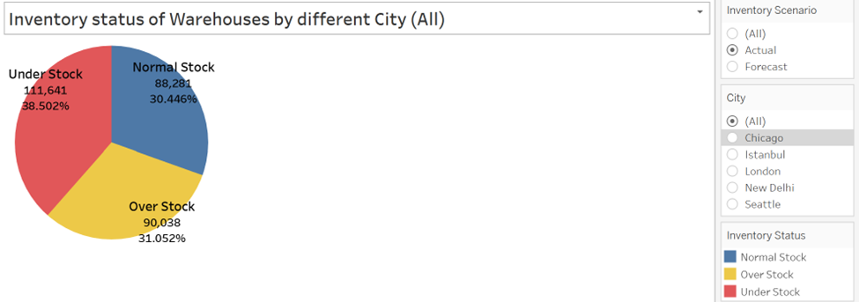**Figure 11**: Actual inventory status (understock, overstock, and normal stock)

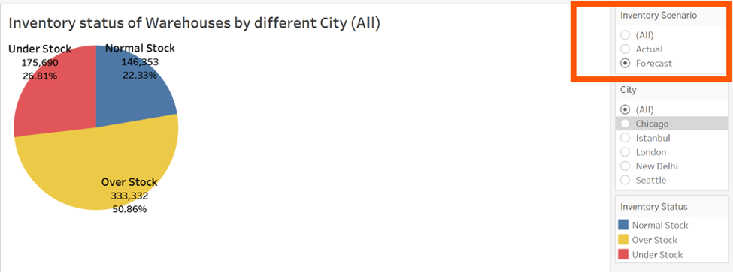**Figure 12**: Forecasted inventory status (understock, overstock, and normal stock)

Emir Halilović et al. state that surplus stock can account for up to 20% to 30% of total stock; nevertheless, ACME's overall overstock reached over 31% (Figure: 11), indicating the urgent need to address this issue. Its prediction for the upcoming year, which takes into account last year and can reach up to 20%, appears to be worse than the previous one (Figure: 12). It might cause issues for the ACME and have a number of detrimental effects, some of which include a rise in expenditures, higher storage and security costs, and expenditure on non-essential products (Lestari, 2022). Nevertheless, an excessive quantity of excess inventory prompts a firm to seek a solution by leasing or constructing a warehouse. While excess may still occur, it may be mitigated with an improved inventory management system.

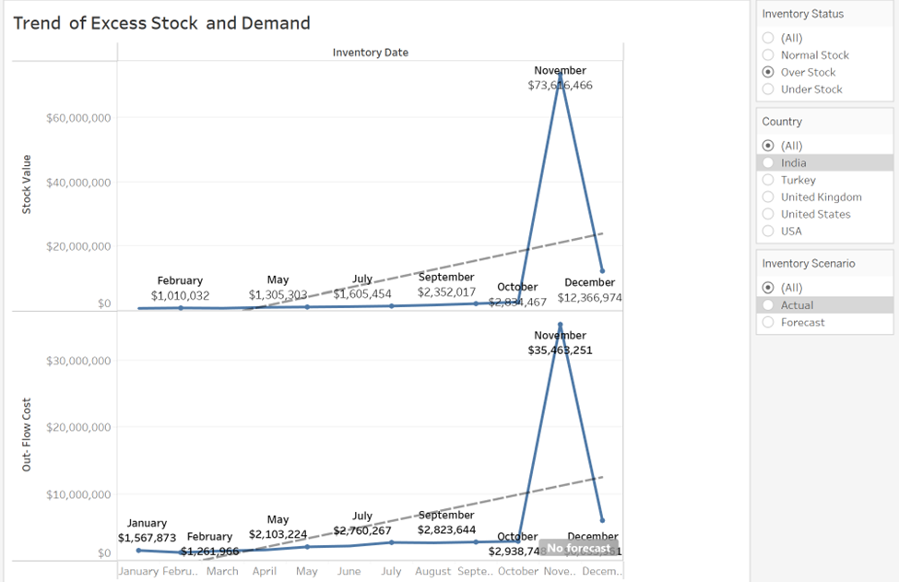**Figure 13**: Excess stock and demand trend

However, based on their pattern, it appears that demand will increase soon, necessitating the production of additional goods in order to meet demand from customers and guarantee supply. Yet, using surplus stock to reduce supply risk is never advised (Emir Halilović et al., 2023).

As (Logic, J., 2021) states, decisions should be made depending on the financial analysis and trend of customer demand for the product. The provided analysis (Figure: 13) shows the total cost of the excess product compared to the outflow of the product (Demand) seems to be significantly high. Reflecting the previous analysis (Figure: 12), it's also showing almost 50% costs of overstock have been kept in the inventory. Although the inflation rate is expected to be

# 6. Conclusion

There is much space for improvement in ACME's inventory and warehouse management practices, according to the findings of our exhaustive analysis. The observed variances in inventory turnover ratios and amounts of surplus stock highlight serious weaknesses in current safety stock estimates and forecasting models. Our recommendations—which include just-in-time (JIT) inventory practices, real-time inventory tracking, and enhanced demand forecasting—emphasize the need for ACME to employ more dynamic inventory management strategies. By implementing these strategies, ACME might create a better-balanced inventory, get rid of overstock and lost sales, and increase overall operating efficiency. Future efforts should focus on refining these strategies and continuously adapting to market trends in order to sustain ACME's competitive advantage in the market (Chopra & Meindl, 2016).

# 7. References.

Bhale, U. A., & Bedi, H. S. (2024). Customer churn construct: *Literature review and bibliometric study. Management Dynamics, 24(1), 154-182.* <https://papers.ssrn.com/sol3/papers.cfm?abstract_id=4694541>

Raj, A., Mukherjee, A. A., de Sousa Jabbour, A. B. L., & Srivastava, S. K. (2022). Supply chain management during and post-COVID-19 pandemic: Mitigation strategies and practical lessons learned. *Journal of Business Research, 142, 1125-1139.* <https://doi.org/10.1016/j.jbusres.2022.01.037>

Wang, G., Gunasekaran, A., Ngai, E. W. T., & Papadopoulos, T. (2016). Big data analytics in logistics and supply chain management: Certain investigations for research and applications. *International Journal of Production Economics, 176, 98-110.* [*https://doi.org/10.1016/j.ijpe.2016.03.014*](https://doi.org/10.1016/j.ijpe.2016.03.014)

Marziali, M., Rossit, D. A., & Toncovich, A. (2021). Warehouse management problem and a KPI approach: A case study. *Management and Production Engineering Review, 12(3), 138-150.* <https://doi.org/10.24425/mper.2021.138530>

Bhale, U. A., & Bedi, H. S. (2024). Customer Churn Construct: Literature Review and Bibliometric Study. *Management Dynamics*, *24*(1 (2024)). <https://papers.ssrn.com/sol3/papers.cfm?abstract_id=4694541>

Braglia, M., Castellano, D., & Frosolini, M. (2016). A novel approach to safety stock management in a coordinated supply chain with controllable lead time using present value. *Applied Stochastic Models in Business and Industry*, *32*(1), 99–112. <https://doi.org/10.1002/asmb.2126>

Emir Halilović, Hadis Bajrić, Melin, K., & Ermin Neimarlija. (2023). Strategies for Reducing Excess and Obsolete Inventory. *New Technologies, Development and Application VI*, 396–410. <https://doi.org/10.1007/978-3-031-31066-9_44>

Hedler Staudt, F., Alpan, G., Di Mascolo, M., & Rodriguez, C. (2015). Warehouse performance measurement: A literature review. *International Journal of Production Research*, *53*, 5524-5544. <https://doi.org/10.1080/00207543.2015.1030466>

JNC, G., M, S. C., & P, C. - Operations research models and methods for safety stock determination: A review. *- Operations Research Perspectives. 2020;7:100164. doi: 10.1016/j.orp.2020.100164.*(- 2214-7160 (Print)).

Mankazana, S., & Mukwakungu, S. (2018). *The Impact of Just-in-Time (JIT) in Inventory Management System and the Supplier Overall Performance of South African's Bed Mattress Manufacturing Companies*.

Marziali, M., Rossit, D. A., & Toncovich, A. (2021). Warehouse Management Problem and a KPI Approach: a Case Study. *Management and Production Engineering Review*, *12*(3). <https://doi.org/10.24425/mper.2021.138530>

McPhail, R., Chan, X. W., May, R., & Wilkinson, A. (2024). Post-COVID remote working and its impact on people, productivity, and the planet: an exploratory scoping review. *The International Journal of Human Resource Management*, *35*(1), 154-182. <https://doi.org/10.1080/09585192.2023.2221385>

Mustafa, N., Sook Ling, L., & Abdul Razak, S. F. (2021). Customer churn prediction for telecommunication industry: A Malaysian Case Study. *F1000Res*, *10*, 1274. <https://doi.org/10.12688/f1000research.73597.1>

Lestari, N. F. (2022). Analysis of Inventory Management in Order to Reduce Overstock (Case Study of TVF Footwear). *International Journal of Current Science Research and Review*, *05*(09). <https://doi.org/10.47191/ijcsrr/v5-i9-48>

Lozić, J., & Čiković, K. F. (2021). The impact of digital transformation on the business efficiency of the New York Times. *UTMS Journal of Economics*, *12*(2), 225–239.

Raj, A., Mukherjee, A. A., de Sousa Jabbour, A. B. L., & Srivastava, S. K. (2022). Supply chain management during and post-COVID-19 pandemic: Mitigation strategies and practical lessons learned. *J Bus Res*, *142*, 1125-1139. <https://doi.org/10.1016/j.jbusres.2022.01.037>

Yang, J., Xie, H., Yu, G., & Liu, M. (2021). Achieving a just–in–time supply chain: The role of supply chain intelligence. *International Journal of Production Economics*, *231*, 107878. <https://doi.org/https://doi.org/10.1016/j.ijpe.2020.107878>

Chopra, S., & Meindl, P. (2016). Supply Chain Management: Strategy, Planning, and Operation. Pearson.

Silver, E. A., Pyke, D. F., & Thomas, D. J. (2016). Inventory and Production Management in Supply Chains. CRC Press.

Krajewski, L. J., Malhotra, M. K., & Ritzman, L. P. (2018). Operations Management: Processes and Supply Chains. Pearson.

Nahmias, S., & Olsen, T. L. (2015). Production and Operations Analysis. Waveland Press.

Wang, G., Gunasekaran, A., Ngai, E. W. T., & Papadopoulos, T. (2016). Big data analytics in logistics and supply chain management: Certain investigations for research and applications. International Journal of Production Economics, 176, 98-110.

Krajewski, L. J., Malhotra, M. K., & Ritzman, L. P. (2018). Operations Management: Processes and Supply Chains. Pearson.

Christopher, M. (2016). Logistics & Supply Chain Management. Pearson UK.